**Home page**

**About us**

## ABOUT US, THE STORY SO FAR

## 

D & E Accessories was born out of a passion for fashion and started life back in 20(fit in year) with a mission to become Cameroon’s biggest fascinator brand.

In our humble beginnings our founder would create beautiful headpieces and accessories for women attending glamorous occasions like weddings, banquets and award ceremonies

With an eye for beautiful design and quality craft, the popularity of her unique hair pieces and headwear has grown across Cameroon and beyond. To keep up with the demand, she has decided to create D & E accessories, an online shop store selling beautifully crafted hats and fascinators at affordable prices.

**HATS & FASCINATORS**

Perfect to add a splash of color to your wedding outfit, whether you're the Mother of the Bride or Groom, or a wedding guest who wants to look fabulous on the big day, our exquisite wedding fascinator’s collection has something for everyone.

D&E is one of Cameroon’s largest online suppliers of hats and hair fascinators for all kinds of events. Our stock consists of a huge variety of styles and color made with the finest quality fabrics and trimmings in the world.

**Our goal**

Our goal is to give you real worth for your money while bringing a mix of beauty, color, glamour and texture to your wardrobe. At D&E we believe in building confidence, class and charisma through our fascinators.

**Our products**

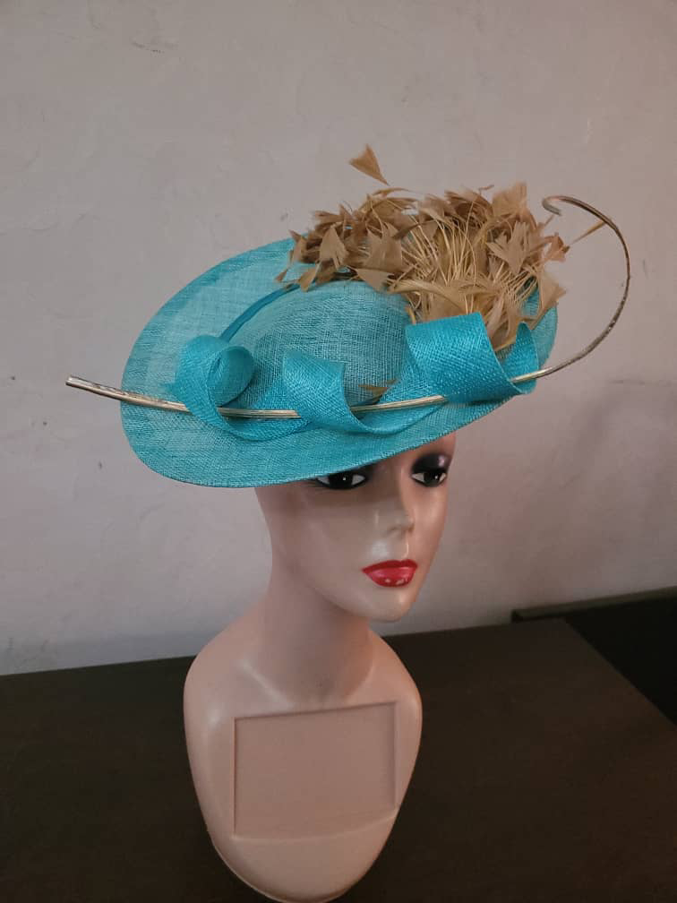

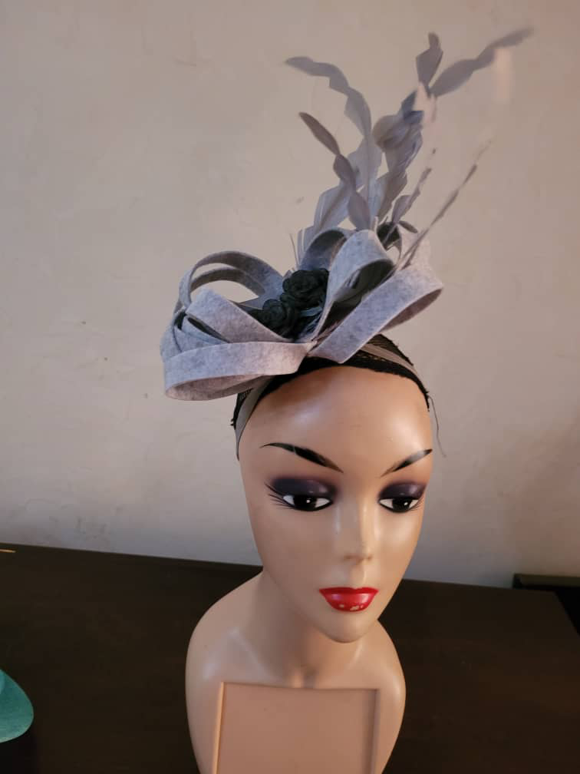

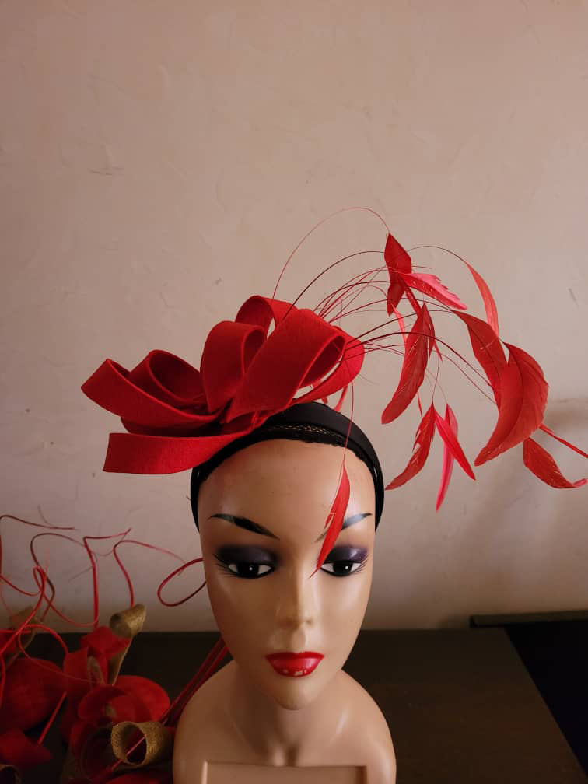

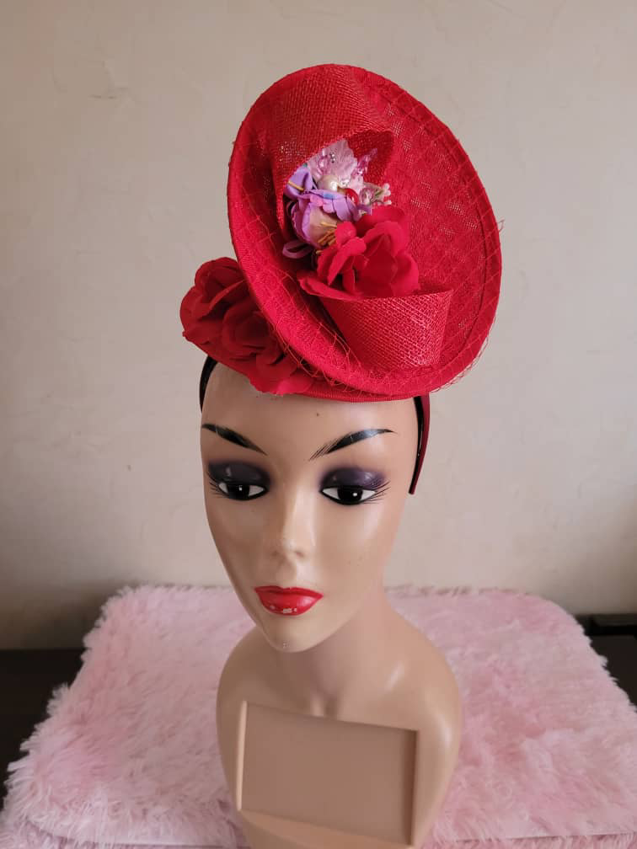

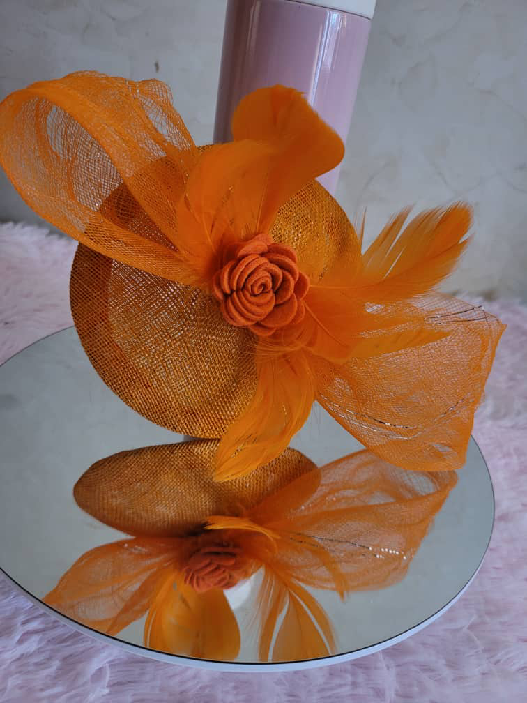

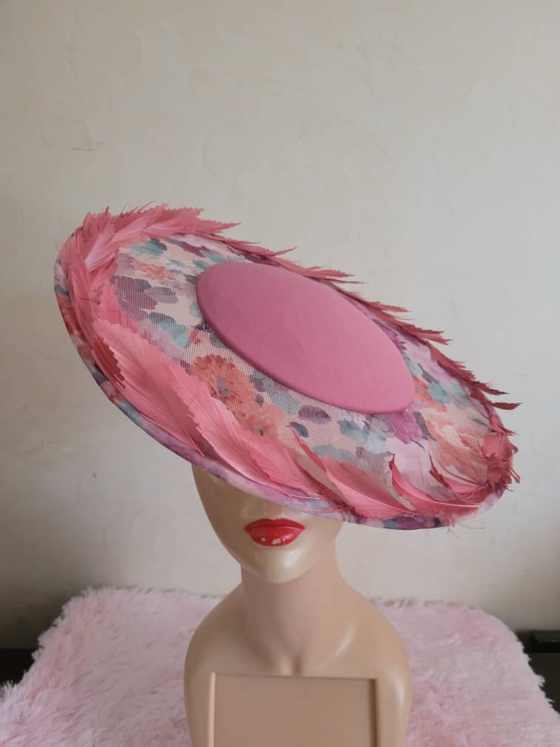

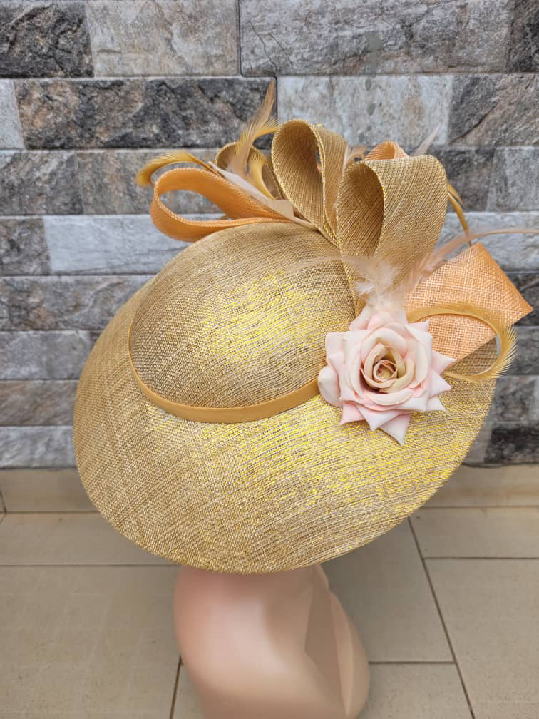

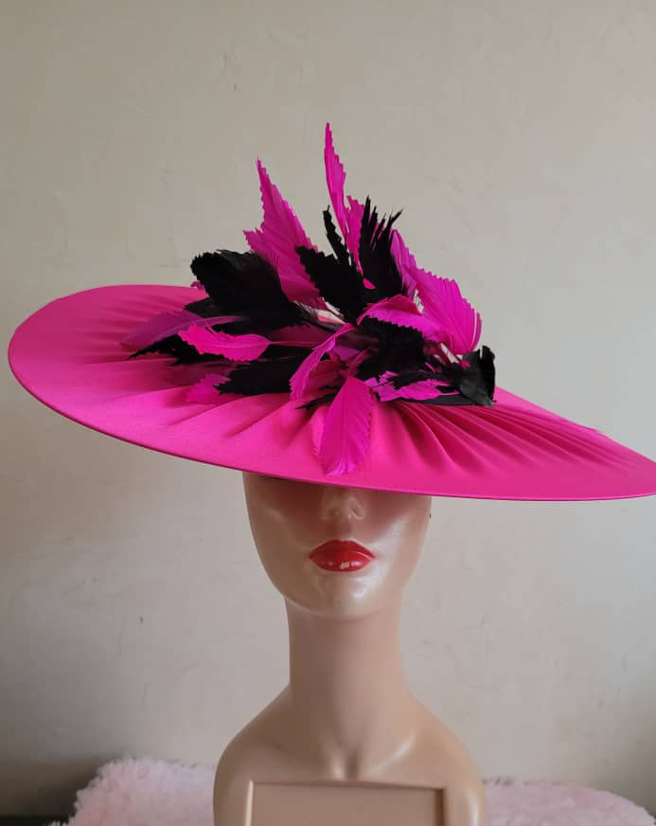

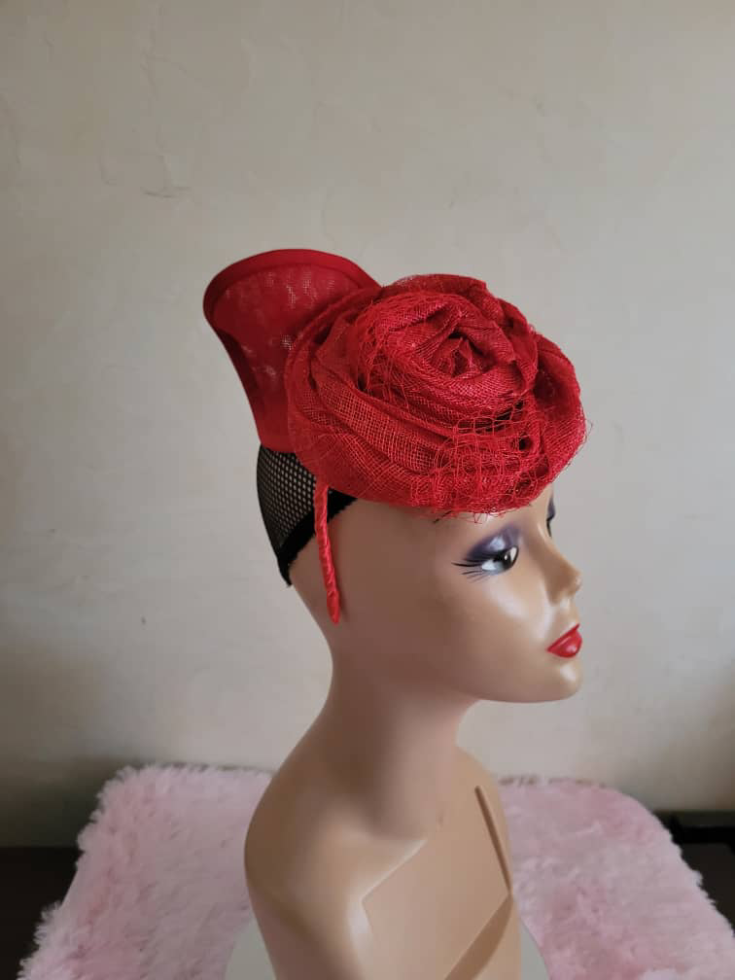

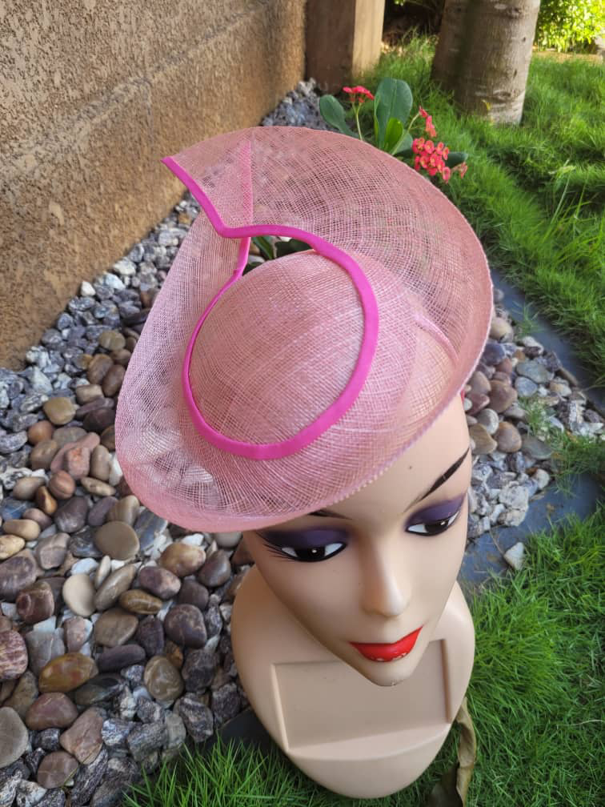

This is proven by the quality of our products and our excellent customer and after sales service.

Accessories with product description

**Return policy**

At D&E we pride ourselves in 100% customer satisfaction and it brings us joy that our clients are well treated during and after buying from us. If for any reason your order arrives damaged or faulty, you may return the goods to us for either an exchange or a refund.

**PROCEDURE FOR RETURNING UNWANTED AND DAMAGED ITEMS**

**>** All returned goods should be with their original packaging with tags attached and in an unworn / unused condition and should be returned to us within 14 days of purchase. If the tags have been removed or if the item is returned outside of the specified time, the returned goods will be rejected.

**>** Please make sure the goods are packaged securely and we recommend that you return your goods by registered post or obtain a proof of posting. D & E will not be liable for non-delivery of returned goods or returns which have been damaged in transit.

**>** You will be liable for the return postage costs and we do not refund shipping costs paid for express delivery upgrades such as next working day delivery.

**>** For international orders, we do not refund any additional fees and charges which you may have incurred, such as import VAT or customs duties.

**>** All returns should be accompanied by a filled copy of our returns form which you can download and print using the button below. Please place the completed returns form inside the package as we will be unable to identify you or process your refund without it.

Click the button below to download our returns form:

**REFUNDS**

**>** All refunds will be processed within 3 days of receipt of the returned goods but please allow 5-10 business days for the funds to be returned to your account.

**>** We can only refund the original payment method used. We will not refund any customs duties from International buyers or original shipping costs.

If you have any queries, please do not hesitate to get in touch.

## SHIPPING INFORMATION

D & E aims to dispatch all orders within 1 business day. For the majority of our International orders, we use FedEx and DHL. For orders within Cameroon, we use bus and train delivery services.



### INTERNATIONAL SERVICES

All international orders are shipped directly from Cameroon on a priority delivery using the fastest service and cheapest rates available.

> European express shipping also available with delivery in 3-5 days using FedEx or UPS.

# REVIEWS

## FASCINATORS DIRECT REVIEWS

At  D&E accessories, we really value your opinions. We take great pride in offering quality hats and fascinators with secure and safe packaging, fast worldwide shipping and a high level of customer service.

To ensure we maintain our high standards of product delivery and client satisfaction, we call on our customers to leave genuine product reviews and share their thoughts and opinions about a product and how it beautified their dressing. These verified customer reviews give our customers a useful insight to what our products are really like and the service they can expect to receive when they shop with us. Read some of our latest customer reviews below:



19/03/2022

[**First Class Service!**](https://stamped.io/go/d3xXaWRnZXRGdWxsUGFnZXw0MTI2NHxyfDcyMDE4NTcy0)

Haven’t worn it yet as bought for a wedding in July. However a perfect match for my outfit, also very reasonably priced and comfortable to wear when tried on

Jackie H.

[*Orange Fascinator with a headband attachment*](https://stamped.io/go/d3xXaWRnZXRGdWxsUGFnZXw0MTI2NHxyfDcyMDE4NTcy0)



06/05/2022

[**Perfect match**](https://stamped.io/go/d3xXaWRnZXRGdWxsUGFnZXw0MTI2NHxyfDcyMDE3NjMx0)

Really happy with my order. The color was a perfect match, exactly like the picture on the website, fast delivery, nicely wrapped, yes i was very happy . I would definitely buy from you...read more

Anonymous

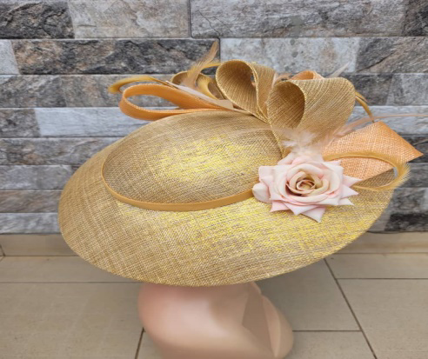

13/02/2022

[**Well-made and as described**](https://stamped.io/go/d3xXaWRnZXRGdWxsUGFnZXw0MTI2NHxyfDcyMDE2MDAx0)

Really quick delivery and such a beautiful fascinator- especially loved having the clip and the clip to choose from

Marion Ongoli.

Gold fascinator



18/01/2022

[**Fascinator**](https://stamped.io/go/d3xXaWRnZXRGdWxsUGFnZXw0MTI2NHxyfDcxOTUxOTY50)

Brilliant service and very quick, the fascinator is such good quality and the color was a perfect match to my dress

Wilma

[*Pink flat top fascinator with black feathers.*](https://stamped.io/go/d3xXaWRnZXRGdWxsUGFnZXw0MTI2NHxyfDcxOTUxOTY50)

.

### CONTACT US TODAY!

If you need help or advice or if you require further product information or support with your order, please use the contact form to get in touch with us. Our customer service team will answer your queries within 1 business day.

**Opening Times:**

Monday - Friday 9am - 8pm

Saturday 10am - 4pm

Sunday - Closed

**Call Us:**  (Insert phone number)

**Follow us on social med: (Insert Social media handles)**

**Email Us:**

(Insert emails)

Bottom of Form